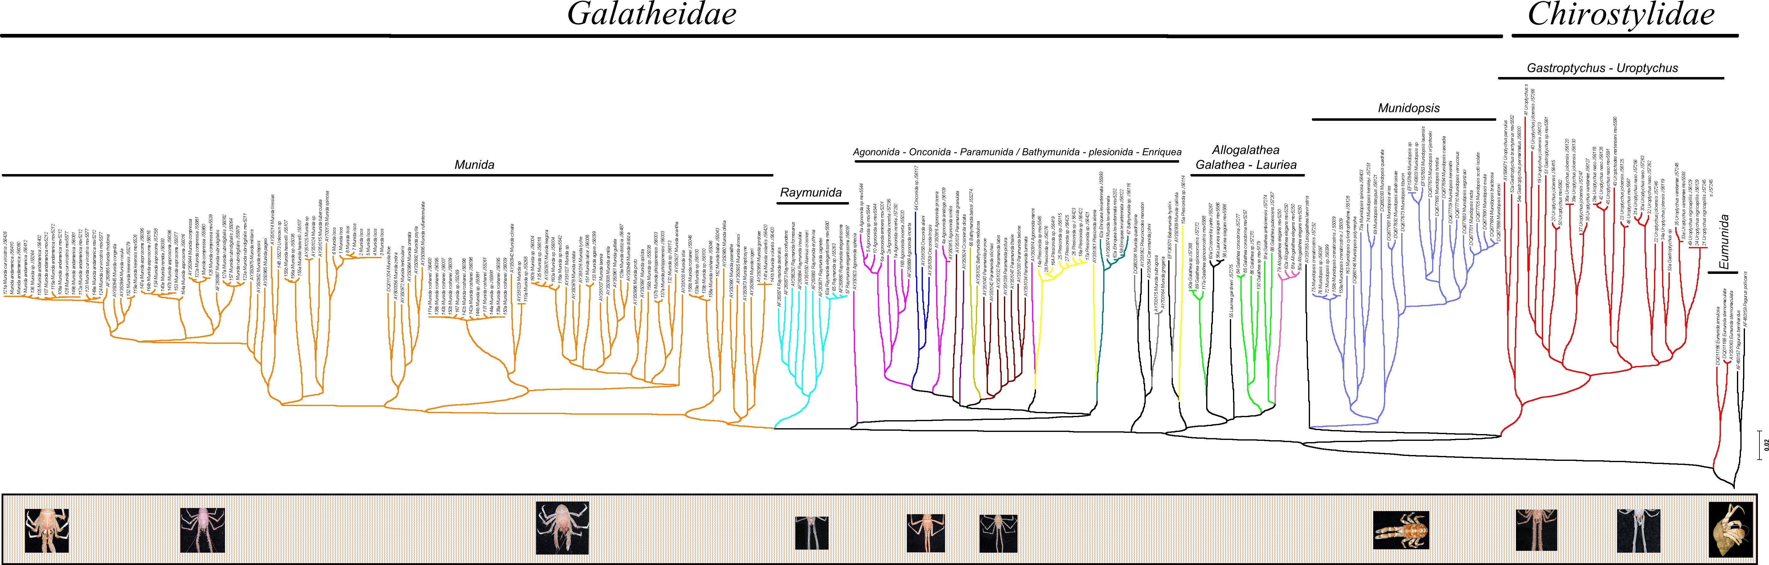

Phylogenetic relationships among 30 of the 255 sequences of Chirostylidae
and Galatheidae squat lobsters inferred from the mitochondrial
Cytochrome oxidase subunit I gene.
Sequences belonging to South-Western Pacific specimens were downloaded from NCBI.

Source: Nikos Andreakis, Australian Institute of Marine Science and CERF Marine Biodiversity Hub

