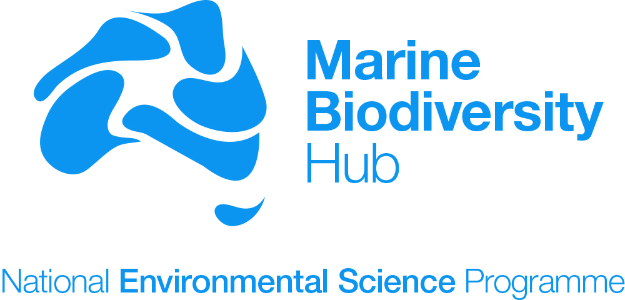

Indigenous Engagement and Participation Strategy
Version 1.1

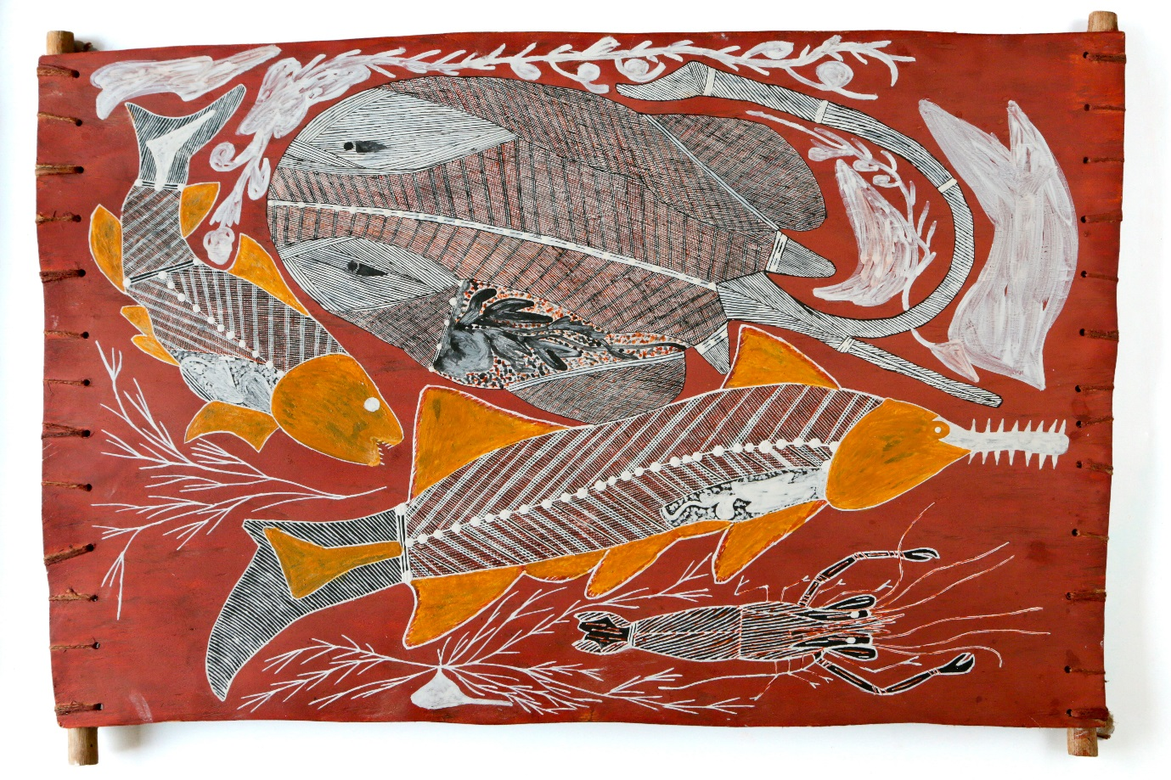

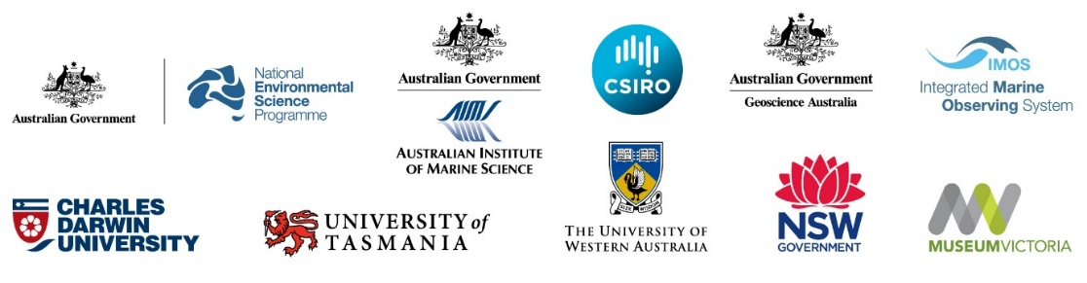
VERSION CONTROL REVISION HISTORY
Version | Date revised | Reviewed by (Name, Position) | Comment (review/amendment type)
V1.0 | 1 May 2015 | Nic Bax, Director | Sent to DoE, Milestone 6
V1.1 | 30 Nov 2015 | Paul Hedge, Deputy Director | Minor amendments to address DoE feedback

Cover image – Berelh (artist Graham Rostron)
The image has been created from an original artwork by Graham Rostron from shark and ray research undertaken by the Marine Biodiversity Hub in northern Australia.
Graham Rostron is a cultural teacher, artist, dancer, musician and song man.
Clan: Baraba
Skin: Balang
Language: Kunay
Mother’s Country: Kutji
Father’s Country: Korlorbirrahda
Dreaming Narin: (Quiet Snake)
Berelh is the Kunay word for the flat one, ‘stingray’. This is a female one. In the day she stays down in the sand ground, where it is cool. At night she swims around looking for tucker, looking for prawn, crab and other tucker.
All night she swims, then goes back and rests herself, she covers herself back up with sand. This stingray is swimming around, she sees the sawfish, the shark and the prawn.
The sawfish we call Djenkundamen, he is dangerous when we are hunting so we be careful. The shark, he’s dangerous too, same like crocodile. The shark we call Wamba.
The little prawn, he’s a day time, night time man, walking around under the water enjoying himself.
These all live in the river where they hunt tucker. They are all tucker for us too on our country.

Contents
Need for strategy 4
The National Marine Biodiversity context 5
Purpose and objectives 6
Implementing objectives 7
1. Promote engagement and participation in Marine Hub research. 7
2. Ensure that Marine Hub research is conducted according to ethical standards. 7
3. Increase cultural awareness amongst all parties. 8
4. Ensure research activities respect Indigenous cultural and intellectual property, and indigenous traditional knowledge 8
5. Ensure Marine Hub research is relevant and can benefit Indigenous peoples and organisations 9
6. Provide opportunities for Indigenous employment, training and skills transfer 10
7. Ensure effective Indigenous participation in Hub governance 11
8. Effectively communicate research results and share knowledge with Indigenous people 11
Review and monitoring performance 12

Need for strategy
The document addresses the NESP Indigenous Engagement Strategy Guidelines (Guidelines) prepared by the Department of the Environment (Department) to ensure effective integration of Indigenous aspirations and outcomes in the National Environmental Science Programme (NESP).
The Department administers Australia’s Environment Protection and Biodiversity Conservation Act 1999 (EPBC Act) that contains specific objectives for engaging and collaborating with Indigenous peoples to protect the environment and to conserve and sustainably use biodiversity, they are:
- to promote a co-operative approach to the protection and management of the environment involving governments, the community, landholders and Indigenous peoples;
- to recognise the role of Indigenous peoples in the conservation and ecologically sustainable use of Australia’s biodiversity; and,
- to promote the use of Indigenous peoples’ traditional knowledge of biodiversity with the involvement of and in co-operation with, the owners of the knowledge.
The Department recognises and respects the knowledge Indigenous peoples have in managing Australia’s land, fresh water and sea country and in conserving biodiversity and cultural heritage. It acts on respect by making Indigenous engagement a priority for its work. The Department’s Indigenous Engagement and Participation Strategy Guidelines for NESP identifies five pillars critical to successful Indigenous partnerships:
Pillar 1: Building trust
Pillar 2: Respectful interactions
Pillar 3: Upholding rights
Pillar 4: Mutual understanding
Pillar 5: Enduring partnerships
All research that is undertaken, irrespective of its nature, will have an impact on Indigenous Australians, and therefore Indigenous engagement and participation is identified as a cross-cutting theme for all NESP hubs in the development of research priorities.
Meaningful, thoughtful and appropriately resourced engagement with Aboriginal and Torres Strait Islander peoples leading to the establishment of collaborative research will result in better research outcomes, as well as wider benefits to Indigenous Australians and to Australian society. Genuine engagement, participation and communication strategies that are relevant to the culture and views of Indigenous Australians are essential to build strong, effective and mutually respectful relationships.
The Marine Biodiversity Hub recognises and values the experiences, perspectives and cultures of Indigenous Australians and supports Indigenous aspirations to maintain, protect and manage their culture, language, land and sea country and heritage. Engagement is an integral component of the service design and delivery processes and good engagement is an ongoing process based on cultural understanding, relationships of trust and continuing honest dialogue.
The Marine Biodiversity Hub partners and researchers recognise that we need to develop our organisational capacity to build and maintain collegial and collaborative research partnerships with Traditional Owners and Indigenous organisations and communities. The primary purpose of this strategy is to provide direction to the Hub’s participants for the effective integration of Indigenous aspirations and outcomes in the development, implementation and communication of NESP funded research.
This Strategy has been prepared taking account of the Australian Government’s Indigenous Advancement Strategy that provides direction on achieving results in the Government’s key priority areas in Indigenous Affairs, including: Jobs, Land and Economy; Children and Schooling; Safety and Wellbeing; Culture and Capability; and Remote Australia Strategies. This strategy also takes account of the AITSIS Guidelines.

The National Marine Biodiversity context
Indigenous Australians are increasingly engaging in and leading coastal and marine research activities in Australia. Some communities have identified their research and management priorities through community participatory processes often leading to community based management plans, for example in Sea Country plans and Indigenous Protected Area Plans. Indigenous ranger groups across northern Australia have demonstrated immense knowledge and capability in coastal areas and sea country. The NESP Marine Biodiversity Hub regards Indigenous engagement and participation in its research program to be important for outcomes in research effectiveness, respecting Indigenous culture and promoting Indigenous aspirations.
Indigenous people have a culture that includes a deep spiritual connection to place that includes reciprocal responsibilities to look after land and sea environments. Indigenous people live around coastal environments in major cities, regional centres, small towns and on Indigenous land. In northern Australia, Indigenous people have interests or outright ownership of significant areas of coastline (particularly in the Northern Territory). Indigenous peoples’ cultural and economic relationship with these environments has existed for at least 45,000 years, thus outdating some modern coastal and marine ecosystems. This relationship includes knowledge and use of lands that now lie beneath the ocean all around the coast, and between mainland Australia and its islands (eg. Tasmania). Indigenous people’s culture, relationships and interests in the coastal and marine environments include use and management of species (eg. shellfish, fish, dugongs, turtles and seabirds), commerce and business (eg. commercial fishing, aquaculture and tourism) and use of these environments by other sectors and peoples, including as researchers.
The Marine Biodiversity Hub will recognise the role of Indigenous peoples in the conservation and ecologically sustainable use of Australia’s biodiversity and promote the use of traditional knowledge. The Marine Hub is committed to improving Indigenous Australian peoples’ engagement in coastal and marine research through partnerships based on respect, trust, reflection and knowledge sharing.
The Hub’s research is national in scope, from the relatively shallow, tropical waters of the Northern Territory to the deep, temperate waters south of Tasmania, and includes estuarine, nearshore and offshore marine environments. It will focus on improving understanding of biodiversity and its supporting habitats and ecological processes, the pressures acting on these and management efficacy for biodiversity conservation and environmental protection. Hub research will seek to promote a cooperative approach to its environmental research by involving governments, the community, land holders and Indigenous people.
The Indigenous Engagement and Participation Strategy being developed by the Marine Biodiversity Hub will substantially build on established collaborations and partnerships with Traditional Owners and Indigenous communities and organisations in northern Australia to support National Environmental Research Program (NERP) funded research. The Indigenous Engagement Strategy (IES) developed by the NERP Northern Australia Hub, and insights and lessons they have learnt, have been used to structure and develop this strategy. Collaboration with other NESP Hubs, particularly the Northern Australia Environmental Resources and Tropical Water Quality Hubs, will continue to provide direction and insights into effective Indigenous engagement in northern Australia, and will collaborate with projects in these Hubs to minimise the burden of engagement for Indigenous peoples (so that communities do not receive excessive and overlapping requests for involvement in projects).
The Hub recognises that Indigenous engagement will need to differ between projects carried out in different areas. While there are clear mechanisms and experience in engaging in northern Australia on projects that include Indigenous communities, and a clear need to develop engagement in nearshore temperate areas where focussed research is scheduled, there is much less experience or direction for engaging Indigenous interests in more offshore areas around Australia, The Hub will need to develop new collaborations, particularly in southern Australia, to understand Indigenous interest in engaging and participating in NESP research. This will include exploring Indigenous interests and capacity to participate in research that is national in scope (ie. as opposed to locally focused research) and research in offshore marine environments.

Purpose and objectives
The primary purpose of this strategy is to provide direction to Hub researchers for the effective integration of Indigenous aspirations and outcomes in the development, implementation and communication of NESP funded research projects. The following objectives have been determined to achieve this purpose:
- Promote engagement and participation in Marine Hub research;
- Ensure that Marine Hub research is conducted according to the highest ethical standards;
- Increase cultural awareness amongst all parties;
- Ensure research activities respect Indigenous cultural and intellectual property, and Indigenous traditional knowledge
- Seek to make Marine Hub research relevant to Indigenous peoples and organisations including meeting identified Indigenous research and management priorities and values;
- Provide opportunities for Indigenous employment, training and skills transfer;
- Ensure effective Indigenous participation in Hub governance; and,
- Effectively communicate research results and share knowledge with Indigenous people and organisations.

Implementing objectives

Promote engagement and participation in Marine Hub research.
The NERP Marine Biodiversity Hub did not develop an overarching Indigenous engagement strategy as almost all its research was focused in offshore marine environments. An exception to this was research on euryhaline elasmobranchs (sawfish and river sharks) in estuaries and rivers in northern Australia where Indigenous interests were identified early and resources dedicated to engage Traditional Owners and Indigenous communities.
The development and implementation of this strategy represents an important step towards fulfilling this objective. The Hub Executive and Research Leadership Team will take an active role in ensuring that project leaders and researchers are committed to engagement with Traditional Owners and Indigenous communities relevant to their research. Resources will be made available for Indigenous engagement and participation in the Hub’s research recognising that engagement needs to be tailored to specific projects and regions. For some projects engagement with Traditional Owners and Indigenous communities will be of critical importance, for example continuing research on euryhaline elasmobranchs in estuaries and rivers in northern Australia. In other situations, such as advancing methods in quantitative analysis to inform environmental reporting, there might be little relevant interest in the immediate research, but useful ways to communicate results to Indigenous bodies at a regional or national level.

Ensure that Marine Hub research is conducted according to ethical standards.
The Hub’s executive will require all project plans to explicitly consider Indigenous engagement and participation, incorporating information about the approach to engagement and participation. The Research Leadership Team will assess all projects regarding the level and type of Indigenous engagement expected, and provide advice back to project leaders on engagement requirements and suggestions for collaboration. The Hub’s executive will also advise as to whether a project requires a formal Research Collaboration Agreement. If so, researchers and potential Indigenous collaboration partners will be provided with a Research Agreement template and the resources to assist negotiating the agreement.
The aim of a Research Collaboration Agreement is to articulate a clear and shared understanding of research intentions, methods, potential results, protection of intellectual property and communication protocols. Such a document should spell out the roles, responsibilities and obligations of each party. It is expected that research agreements will result in greater understanding and acceptance by non-Indigenous Hub researchers of Indigenous people’s knowledge systems, cultural values, perceptions and rights and a greater understanding by Indigenous people of research methods, goals and institutions.
The Australian Government requires that research is conducted to the highest ethical standards with respect for Indigenous priorities and values. The Guidelines for Ethical Research in Australian Indigenous Studies were published by the Australian Institute of Aboriginal and Torres Strait Islander Studies (AIATSIS) in 2000 and revised in 2011. The document guides research ethics, embodies the best standards of ethical research and human rights and provides principles on respect for the rights of Indigenous Australians, including their right to full and fair participation in any processes, projects and activities that impact on them. It identifies as essential that Indigenous people are full participants in research projects that concern them, share an understanding of the aims and methods of the research, and share the results of this work. At all stages, research with Indigenous peoples must be founded on a process of meaningful engagement and exchange between the researcher and Indigenous people.
Principles from these guidelines provide a coherent and clear national standard and have been adopted to assist Hub researchers achieve the highest standards of ethical research.
Researchers must ascertain whether their project requires ethical approval from a recognised human research ethics committee following processes consistent with the National Statement on Ethical Conduct in Human Research (2007) http://www.nhmrc.gov.au/health-ethics/human-research-ethics-committees-hrecs. Approval must be obtained prior to the commencement of research, as it cannot be granted retrospectively. This is a contractual requirement for all Hub partners and sub-contractors.

Increase cultural awareness amongst all parties.
The Marine Hub acknowledges the need to promote the importance of Indigenous cultural awareness and competence (e.g. formal cultural awareness training courses) for its researchers and encourage their participation in training opportunities arranged by the Hub, its research partners or other institutions.
The Hub Executive will identify opportunities for cultural training and for Indigenous partners to increase their understanding of research goals, methods and institutions. The Hub will support the development of cultural competency among researchers through the participation in cultural awareness, cultural induction and cultural exchange processes as appropriate for the context of each project. Researchers will be encouraged to participate in a cultural awareness course before commencing a research project, and to participate in any Hub program activities designed to enable Indigenous collaborators to be mentored by research partners and organisations.

Ensure research activities respect Indigenous cultural and intellectual property, and indigenous traditional knowledge
Research with Indigenous people requires consultation, negotiation and consent. Consultation and negotiation should achieve mutual understanding about the proposed research and opportunities for Indigenous involvement in research planning.
Consultation involves an honest exchange of information about aims, methods, and potential outcomes for all parties. It provides an opportunity for researchers and community members to say what they are hoping will come out of the research and how they can contribute.
Indigenous peoples, like any other potential research collaborator, need to be well informed about the aims and methods of a research project, its implications and potential outcomes, so they can decide whether the project is in their interests or not, and offer suggestions for ways of enhancing the relevance of the project.
It is important that researchers work with the appropriate Indigenous authorities. For instance, Traditional Owners may have different interests to those of the general resident community. Hub researchers should develop an understanding of the local Indigenous history and current issues in the area they propose to work, including respecting cultural protocols, prior to commencing on-ground research.
Researchers must respect the Intellectual Property rights of Indigenous peoples in relation to knowledge, ideas, cultural expressions and cultural materials. These rights are part of the heritage that exists in the cultural practices, resources and knowledge systems of Indigenous people that are passed on by them in expressing their cultural identity (AIATSIS 2006).
In conducting its research activities the Marine Hub will ensure that:
- The contribution of resources, knowledge and access to other information made by Indigenous peoples is acknowledged by way of rights in the research outputs and/or access to research results;
- Research outcomes are made available to the Indigenous persons or community in a form that is useful and understandable;
- Indigenous co-researchers are recognised in publications to which their knowledge and endeavours have contributed;
- Researchers are aware of and commit to the equitable sharing of the benefits derived from the utilisation of Indigenous knowledge;
- Protection of cultural IP is provided for in Research Collaboration Agreements; and,
- Acknowledgement of Country and Welcome to Country in the case of larger gatherings are undertaken as respectful acknowledgements of Australia’s Traditional Owners, and where appropriate in Hub publications.

Ensure Marine Hub research is relevant and can benefit Indigenous peoples and organisations
Indigenous people, as residents, landowners and managers have many questions about management that need to be researched. Some communities have identified their research and management priorities through community participatory processes often leading to community based management plans, for example in Sea Country plans and Indigenous Protected Area Plans. Where appropriate, research should recognise and support these research priorities.
Indigenous people should have the opportunity to understand, influence and participate in research activities. Indigenous people express a strong desire to develop their skills in participatory research with non-Indigenous researchers, government staff and others. Empowering local people to act as researchers should encourage the development of a constructive understanding of research practice and will ensure that people, relationships and local politics are addressed appropriately.
There are many Indigenous representative organisations that can help facilitate broader community connections. It must be remembered that culturally, often one group or individual may not be able to represent the broader interests of Indigenous communities outside their traditional lands, so it is important to ensure all communities are consulted appropriately. The cost of consulting face-face with Indigenous communities should be factored into budgets where this is required, in addition to appropriate timelines for doing so.
Traditional Owner groups may vary from place to place and represent a breadth of cultural practices, languages, histories and spiritual belief. As such, researchers may need to undertake multiple consultations and obtain consent or undertake agreements with multiple groups. The appointment of an interpreter, cultural broker or cultural mentor may be beneficial at the commencement of discussion as well as during the research process, and should be budgeted for accordingly.
A cultural broker can play a crucial role at the start of the research process to bridge and facilitate a smooth introduction and interaction between the researcher and Indigenous communities. They can provide a valuable service throughout the research process especially if there is need for negotiation or mediation. A cultural broker may be a person from the community or a professional person who has an understanding of the views, cultural values, beliefs and practices of both parties. The person will have contact with both the researchers and the participant group or community.
A cultural mentor is someone who can teach you about local customs and norms and is involved throughout the research process providing advice about views and cultural values, beliefs and practices and associated protocols which need to be followed. They will have a general understanding of the views, cultural values, beliefs and practices of the participants but might not have contact with Indigenous communities during research processes. A cultural mentor may be a person from the participating group or community or a professional/academic person and the role may overlap with that of cultural broker, with one person carrying out both tasks.
The Hub may allocate resources (in collaboration with other NESP hubs) for the employment of Indigenous Research Facilitators regionally located across northern Australia. The Hub may also allocate resources for a cultural broker, cultural mentor or other expert to assist with implementation of this strategy. Theme and project leaders should contact the Hub Executive if they are considering engaging cultural brokers or mentors.

Provide opportunities for Indigenous employment, training and skills transfer
Indigenous people have a reasonable expectation that research involving them or their traditional land and sea country will provide benefit to them. Alongside benefits (current or future) to the landscape and/or stated local goals (for example as articulated in local management plans), and depending on the nature of the research, additional benefits might include payment for research work, capacity building, training, and development of livelihoods, opportunities and joint publications.
These benefits also extends to real, on-ground outcomes for Indigenous Australians arising from publicly funded research. Building strong partnerships and facilitating knowledge exchange enables identification of areas and issues of social, economic, cultural and spiritual significance to Indigenous communities. Early and meaningful engagement removes the need for assumption and improves opportunity for appropriate consideration and integration of Indigenous benefit in research development.
Indigenous knowledge systems and processes must be respected and Indigenous participation as collaborators encouraged and rewarded. Indigenous employment should, where possible, be undertaken through organisations that have appropriate institutional arrangements.
Opportunities and support should also be provided for Indigenous participants to represent and promote research projects, activities and findings outside their communities (e.g. at conferences) and to participate in research communication through joint authorships and public presentations.
Through its research projects and collaborative reach the Hub will explore with Traditional Owner partners opportunities to build capacity through Indigenous employment, training and skills transfer. Within the resources available to the Program, Hub activities should seek to employ Indigenous people in research, technical, field support and administrative positions, at appropriate levels of payment. Differing types of participation are likely to require different pay rates, for example, for technical assistance, consultation, liaison, translation, expertise in ecological and cultural knowledge. Theme leaders and project leaders should contact the Hub Executive if opportunities for Indigenous employment, training and skills transfer arise during the course of their research projects.

Ensure effective Indigenous participation in Hub governance
The NESP Marine Biodiversity Hub will provide for direct Indigenous participation in the Hub’s governance committees. In the first instance the Hub will seek Indigenous participation in the Research-users Committee that provides advice on research-user research interests, needs and priorities. Opportunities to enhance Indigenous participation in the Hub’s governance committees will be investigated (e.g. participation in the Steering Committee), particularly in seeking the appropriate balance between providing advice on national or regional scale research and research focused more locally. For some projects an appropriate Indigenous representative(s) will be included to provide advice and insights to guide the Hub’s approach to research.
Where appropriate the Hub will also inform the Indigenous Advisory Committee (IAC) on research projects, progress and outcomes. Established under the EPBC Act, the IAC advises the Minister for the Environment (the Minister) on the operation of the EPBC Act, taking into account the significance of Indigenous peoples' knowledge of the management of land and the conservation and sustainable use of biodiversity.

Effectively communicate research results and share knowledge with Indigenous people
Knowledge brokering and communication is a critical element of the Hub’s approach to effective research and particular attention needs to be given to ensure that research is packaged and delivered appropriately to relevant Indigenous groups. Communication is central to developing trust and good will. Materials produced must be appropriate to the audience being engaged, considering language and literacy, and understanding of scientific concepts. Regular reporting is very important and should be budgeted for, including the development of bilingual communication tools.
Researchers will foster a clear understanding of what Indigenous communities see as desirable in terms of reporting and communication products and take responsibility for becoming familiar with other research activities that have been undertaken so that their project can build on previous studies. Researchers will minimise consultation burden on Indigenous communities by linking with other current research initiatives where appropriate, for example through engagement in the NESP Indigenous Community of Practice facilitated by the NESP Northern Australia Environmental Resources Hub. Local research needs should be incorporated into the project where possible and synergistic opportunities sought to ‘stitch together’ longer term benefits from other projects operating in the area.
Consultation and negotiation is a continuous two-way process and the responsibility for consultation and negotiation is ongoing. It is important to ensure that leaders of projects with significant opportunities for Indigenous engagement allow a realistic amount of time for effective collaboration and project development, implementation and communication. These research projects should be regularly reviewed to allow continuing opportunities for consideration of the research by the community and sufficient time should be allocated to account for regular reporting, remoteness, community activities and contingencies. Allowing time for community meetings as well as social interaction with the community will assist in building stronger relationships.
Where appropriate, the Hub will provide resources to project leaders for communicating their research and sharing knowledge with Traditional Owners and Indigenous people, for example to develop and package bilingual products or those that meaningfully integrate Indigenous knowledge.

Review and monitoring performance
This strategy is considered a living document and will be updated as required throughout the life of the NESP. The annual research plan progress report NESP will provide an important trigger for periodic review of the strategy and effectiveness of its implementation. Key performance indicators will be developed to provide feedback on the effectiveness of the Hub’s approach to Indigenous engagement and participation. The Department of the Environment has procured expertise to develop a NESP Monitoring and Evaluation Plan. The Hub will identify its key performance indicators after the NESP plan is established. The Knowledge Broker will be responsible for reviewing and updating this strategy.

