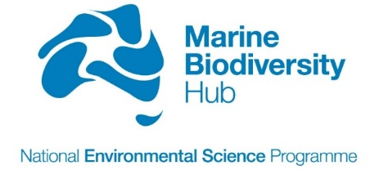

Communication Plan

Version 1.1

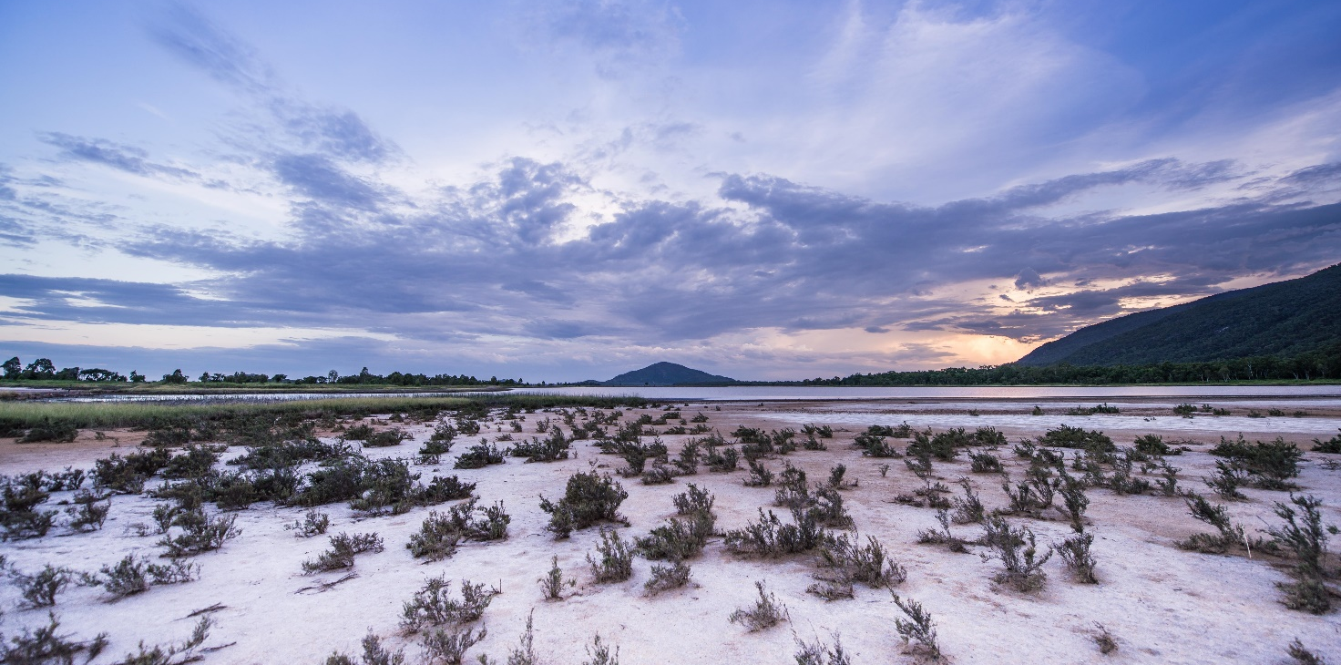
Tobias Baumgaertner

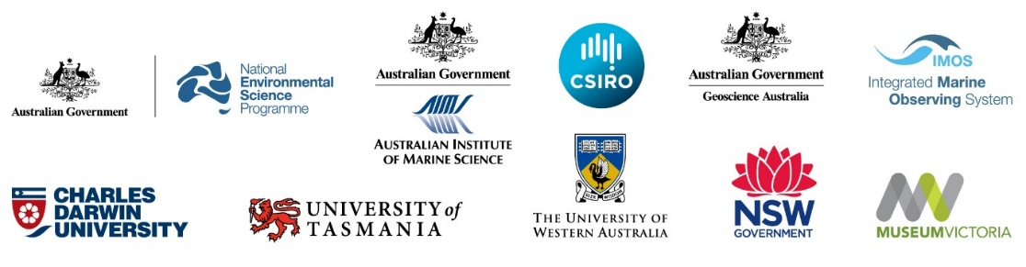

VERSION CONTROL REVISION HISTORY
Version | Date revised | Reviewed by (Name, Position) | Comment (review/amendment type)
V1.0 | 1 July 2016 | Nic Bax, Deputy Director | Approved Plan
V1.1 | 1 Nov 2016 | Paul Hedge, Deputy Director | Edits to Appendix B

Contents
Purpose of plan 4
Responsibility for communications (people) 4
Background and approach 4
Communication objectives 5
Actions to implement plan 5
Action 1: Identify, develop and use the right mix of communication channels and tools 6
Communication Channels 6
Communication tools 9
Action 2: Engage Hub researchers in developing communication products and activities and provide opportunities to enhance their capacity for communicating research 11
Action 3: Develop, maintain and implement an annual communication schedule 11
Action 4: Review communication plan annually 11
Appendix A – Target audience for NESP Marine Biodiversity Hub 12
Appendix B – 2016 Communications schedule for NESP Marine Biodiversity Hub 14
Appendix C - Social Media Guidelines for NESP Marine Biodiversity Hub 15

Purpose of plan
The National Environmental Science Program (NESP) Marine Biodiversity Hub is a partnership of 10 research and management agencies engaged in research for understanding and managing Australia's oceans and marine environments. This plan outlines communication objectives and approaches for the Hub, and highlights actions intended to build communication capacity and effectiveness. It provides the foundation for a shared understanding among Hub research partners, researchers and their research-users and stakeholders including the Department of the Environment. Specific, priority activities for 2016 are scheduled in Appendix A.
The plan is designed to support delivery of the Hub’s research plans and complement its Knowledge Brokering and Communication Strategy and Indigenous Engagement and Participation Strategy. It is a ‘living document’ and will be reviewed annually.

Responsibility for communications (people)
Hub director and lead spokesperson | Nic Bax is the lead spokesperson and primary communicator for the Marine Biodiversity Hub and manages the direction of Hub communication.
Knowledge broker | Paul Hedge is the knowledge broker for the Hub and shares responsibility for overseeing communication.
Science support officer | Annabel Ozimec provides communication services including website management (input, maintenance, imagery database, reports and publications database), managing Chirps and related staff emails, database management, promotional items (posters, bookmarks, postcards), and conference promotion and other exhibitions.
Communication consultant | Bryony Bennett provides communication services including planning, writing, editing, photography and project management (brochures and other promotional materials, synthesis reports, web content, social media, videos).
Hub researchers | Research theme leaders, project leaders and project research teams all have a role to play in communicating the Hub’s research. Researchers will work closely with the Director, Knowledge Broker, Science Support Officer and Communication consultant.

Background and approach
  - Established communication tools and activities
Established communication tools for the Marine Biodiversity Hub include the website http://www.nespmarine.edu.au/, a quarterly e-newsletter, the Department’s Chirp e-newsletter, internal emails, synthesis brochures, videos, annual research highlight documents and major research reports at the culmination of multi-year funding cycles. A significant communication effort (sponsorship) has been devoted to the annual Australian Marine Sciences Association conference, and a collection of marine biodiversity images has been displayed as a travelling exhibition. Promotional events have been held, such as the visit of the Environment Minister, Greg Hunt, to Hobart in 2015 to launch the NESP Marine Biodiversity Hub.

  - Opportunities for change to meet a broader target audience
The target audience for the NESP Marine Biodiversity Hub (Appendix A) is broader than for the NERP Marine Biodiversity Hub, and the project portfolio has a stronger focus on community engagement, including citizen science. Projects focused on Reef Life Survey, coastal habitat restoration, and the National Outfall Database have community involvement. Other projects such as White Shark population estimation and Southern Right Whale monitoring have the potential for attracting a following on social media. There are also art-science collaborations, and an increasing range of mapping products available for public access. At the same time, the mix of communication channels has broadened and shifted from (primarily) traditional print media to social media supported by imagery and video. Several Hub partner agencies use social media, for communication and as a research tool.

Communication objectives
- To raise the profile of the Marine Biodiversity Hub and the National Environmental Science Program among government and industry stakeholders, the marine research community and the general public.
- To communicate and promote the Marine Biodiversity Hub’s research interests and achievements to government and industry stakeholders, the marine research community and the general public.
- To encourage, enable and build the capacity of Marine Biodiversity Hub researchers and partner agencies to participate in Hub communication activities.

Actions to implement plan
The Hub will implement four broad actions to achieve the objectives of this plan:
- Identify, develop and use the right mix of communication channels and tools (pp 4-8)
- Engage Hub researchers in developing communication products and activities and provide opportunities to enhance their capacity for communicating research (p 8)
- Develop, maintain and implement an annual communication schedule (p 8)
- Review the communication plan annually (p 8)

Action 1: Identify, develop and use the right mix of communication channels and tools
The Hub will use a mix of communication channels and tools to achieve the objectives of this strategy, including: mini-campaigns, website, direct emails, synthesis products, events and social media. Following is a list of tools and actions the Hub will use to target communication to its research-users and stakeholders.

Communication Channels

Mini campaigns
A major focus of Hub communication will be ‘mini campaigns’ focused on priority research projects to promote Hub interests and achievements and the NESP. Mini-campaigns will combine a mix of communication channels and tools. Priority projects will be identified early in the annual cycle and incorporated into the annual communication schedule.
  - Actions
- Identify priority projects for mini-campaigns.
1.2 Engage with researchers and relevant communication groups and stakeholders to develop the approach and scope available resources.
1.3 Plan the timing and mix of communication tools and channels for each mini-campaign and share campaign plans with identified stakeholders.
1.4 Implement mini-campaign plans and evaluate effectiveness.

Marine Biodiversity Hub Website

The Hub website http://www.nespmarine.edu.au/ provides access to written outputs and products, including research plans, governance structures and published articles, reports, brochures, newsletters, videos, images, posters and news, including media releases. The website is based on the Drupal database so all information is searchable. Access to all CERF and NERP Marine Biodiversity Hub documents is also provided. Updates and maintenance of the website is an ongoing task.
A new function, to be added incrementally, will feature website entry points that align with research-user interests (e.g. structured around environmental values). Two to six content packages including facts, images, video and mapping functionality (for values such as Commonwealth Marine Reserves) will be added each year.

Actions
1.5 Maintain and refine website to ensure information is current and relevant to researchers, research-users and stakeholders
  - Develop research-user content and entry points to website.
  - Develop prototype focused on the Oceanic Shoals Commonwealth Marine Reserve providing synthesis of information.
  - Develop site architecture, design and functionality as the foundation for a group discussion to develop a brief for the web developer.
  - Commission and work with web developer to create prototype website.
  - Seek and respond to feedback from research users.

Social media
The Hub has a presence with videos on YouTube and will move further into the social media realm in 2016, initially with a presence on Facebook and Twitter. This move will be supported by investment in video production and high-quality images, and will underpin ‘mini campaigns’ for selected areas of research.
Involvement in social media will present the Hub as being in touch with modern communication, and enable participation in discussion on relevant issues. It will provide a responsive medium for publically sharing research highlights, images and videos and other achievements, and foster connections and participation among researchers, partners and stakeholders. Analytical information will provide a rare means of measuring communication engagement.
Actions
  - Prepare Hub social media guidelines to generate a shared understanding about the Hub’s approach and practices for social media (see Appendix C).
  - Identify and develop social media content.
  - Monitor Facebook and Twitter to find people, groups and ‘hashtags’ to interact with.
  - Set up a Google alert for relevant topics.
  - Create Facebook and Twitter accounts.
  - Add social media icons/links to Hub website.
  - Set up a social media management service (e.g. Hoot Suite).
  - Review progress within six months of commencement.

Events: conferences, public events and creative initiatives
The Hub has a history of sponsoring relevant Australian research conferences, primarily the Australia Marine Science Association annual meeting. More requests are received for sponsorship than can be met. The Hub sponsors conferences where it has a significant engagement, ie. specific workshops led by Hub researchers and/or profiling Hub research.
Communication support will be provided for conferences at which the Hub has a major role, such as through significant sponsorship. For conferences with low-level Hub involvement, opportunities for highlighting workshops, presentations and posters involving Hub researchers will be monitored. Opportunities to be involved in relevant creative events, such as art/science collaborations, can be a great way to engage with the public, and will be assessed as they arise.
Actions
  - Sponsor and attend annual Australian Marine Science Association Conference
  - Identify conferences (e.g. annual GeoHab Conference) involving Hub presence and ensure Hub researchers are provided with appropriate communication materials.

Traditional media (including online publications)
Media releases and articles are distributed, and/or key journalists directly notified where appropriate as part of communication campaigns, and opportunistic promotion of high-profile publications, events, field research etc. Target media differ for different stories, and may include publications such as The Conversation, mainstream and local papers. Stakeholder and partner publications include the NOPSEMA publication The Regulator, the AFMA online news feed and the IMOS publication Marine Matters.
Avenues for media release distribution include the communication networks of partner agencies, direct contact with journalists and publications via social media (Twitter), and, for journal articles, through online science media services such as Scimex https://www.scimex.org/ (Australia and NZ) and Eurekalert http://www.eurekalert.org/. The Australian Government Media Services distributes government-related media releases. Commercial media distribution lists, and an existing list of Hub media contacts, also are available if required.
Actions
  - Liaise with partner communication groups to foster joint communication arrangements.
  - Develop and maintain contact list (including social media) of key journalists and publications that cover marine biodiversity management.

NESP Chirp Newsletter
Short stories are contributed weekly to the Department of the Environment newsletter. An email is circulated each Friday to inform the Hub communication team of action required in relation to upcoming ‘Chirps’. Each week, the Hub Secretariat (prompted by the Friday Chirp email) decides whether or not to ‘post’ the Chirp item on the website, and or to social media. A spreadsheet of potential Chirp items is kept here: https://www.dropbox.com/home/Chirp%20-%20tracking%20spreadsheet?oref=e&preview=Marine+Hub+Chirp+contributionsV2.xlsx
Action
  - Submit weekly news items to promote the Hub’s achievements and interests

Weekly internal email
A weekly email to Hub staff provides notice of the weekly Chirp article. It is proposed to extend this email to also feature an ‘image of the week’ that links to a related item such as a news story, video, project report, web update or journal publication. The expanded internal email aims to help connect Hub researchers and share awareness of Hub research and communication activities.
Action
  - Develop and extend the weekly internal email to Hub staff and researchers to further build researcher engagement with the Hub

Communication tools

Synthesis reports, brochures and fact sheets
Well-presented summaries of research results, available in print or digital format, or both, will be created as needed by partners or by Hub communication staff and/or external providers. These products are developed mainly for the benefit of research users and can be promoted through traditional and social media.
Action
  - Identify and develop synthesis products to enhance research-user understanding of the Hub’s research

Videos and images
Videos attract attention on social media and traditional media, are a simple way of packaging and conveying research highlights, and can also be used at events and in presentations, They can be a mix of professionally produced videos and less-professional ‘video bursts’, ranging from 30 seconds to five minutes. Still images and animations can be included and used effectively.
The Hub will produce three professional videos (project-managed by Hub) and three lower budget videos put together by the communication team per annum. The videos will feature projects prioritised for mini-campaigns, or stories about research-user values, or may profile Hub researchers.
Actions
  - Identify and prioritise video topics.
  - Engage with research partners, researchers and professional videographer/animator to produce a pilot NESP Marine Biodiversity Hub-branded video.
  - Create the first draft video and seek feedback from partners and research users.
  - Establish dedicated video section/pages on Hub website.
  - Develop a ‘daily communication checklist’ for voyages of discovery that covers tasks such as a daily blog, and the capturing of images and video of people and gear deployment, to support public interest campaigns. Daily checklist for communication.

High-quality images are vital to effective communication. The Hub website features an image library and images are included in research reports and collected from researchers to illustrate research reports and stories. While some images are outstanding, there is scope to greatly improve overall image quality, particularly on research voyages. Initiatives being undertaken to improve the availability of high-quality images include training, protocols, feedback and incentives for researchers, and the engagement of professional photographers.

The image library on the Hub website is a great resource for communication activities such as web pages, banners, reports and brochures, and a potentially useful resource for partners, research users and the general public. Researchers are encouraged to upload images by featuring images on the homepage of the website, in the weekly email to staff, and on social media. Providers of outstanding images will be recognised and rewarded by the Hub Secretariat.
Actions
  - Create a simple ‘poster’ protocol for photography of on-board samples.
  - Organise a photography workshop for annual Hub staff gathering in November (Ian Mcleod (JCU) has offered to provide a training workshop)
  - Commission professional photography where appropriate to support mini-campaigns and strong media opportunities such as high-profile publications.
  - Develop and implement incentives for researchers to capture and share video and images of their research experiences
  - Simplify data entry form for image library (see Image library section below) and encourage uploading of images by researchers

Promotional materials
Banners and posters will be created as needed, by partners or by Hub communication staff and/or external providers. The Hub has produced a new poster for distribution at the AMSA national conference each year. This year a poster on sharks and rays of northern rivers is being developed for researcher Peter Kyne. Other promotional items such as hats, postcards and bookmarks, will be produced as needed.
Actions
  - Create a Marine Biodiversity Hub pull-up banner for use on mini-campaigns and events
  - Identify, develop and circulate promotional materials for use in min-campaigns and events
  - Identify focus for the 2017 Hub poster (e.g. swath map images used by Vanessa Lucieer in ‘visual soundings’)

Action 2: Engage Hub researchers in developing communication products and activities and provide opportunities to enhance their capacity for communicating research
The Hub’s research and project leaders collaborate with more than one hundred researchers around Australia and overseas. Research and project leaders have an important role in developing communication products and creating the opportunities to communicate their research to research-users and stakeholders. They also need to create opportunities for early career researchers to participate in the science communication process.
Actions
  - Research and project leaders will identify opportunities to communicate their research achievements, and where appropriate, participate in communication events.
  - Research and project leaders will identify and provide opportunities for early career researchers to participate in the science communication process.

Action 3: Develop, maintain and implement an annual communication schedule
There will be many opportunities for the Hub to communicate its research achievements and interests and to promote the NESP. It is important that communication events are prioritised, scheduled and designed to be achievable (i.e. within the limits of available resources) and that his information is shared within the Hub and with key stakeholders and research-users.

Action 4: Review communication plan annually
The communications plan will need to be reviewed annually to ensure it is current and relevant. Reviews will include an evaluation element that will consider questions such as:
- Did we implement actions outlined in the plan?
- Have we achieved our objectives?
- Did we reach the right audience?
- Did we use the right channels and tools?

Media campaigns can be evaluated to a degree by the number of media outlets that ran the story, and estimated readership. Social media metrics can give an idea of interest in social media communication activities, including the response of certain target audiences. Reponses to direct emails can be monitored. Stakeholders can be surveyed, and/or asked questions in workshops, phone discussions etc.

Appendix A – Target audience for NESP Marine Biodiversity Hub
The Hub has identified a broad range of targets for communication (Table 1). Communication activities will be essential to the success of the Hub and they will need to be developed to target a range of research-users and stakeholders.

Table 1: The NESP Marine Biodiversity Hub’s list of targets for knowledge brokering and communication
Type | Organisations/entities
 | The Minister for the Environment,
Research grant provider (≤50% funds) | Department of the Environment (DoE)
Research partners (≥50% funds) | Australian Institute of Marine Science  Charles Darwin University  CSIRO  Geoscience Australia  Museum Victoria  NSW Government – Department of Primary Industries  NSW Government – Office of Environment and Heritage  University of Tasmania – Institute for Marine and Antarctic Studies  University of Western Australia
Research collaborators | Clean Ocean Foundation  Integrated Marine Observing System  James Cook University  Malak Malak Ranger Group  Murdoch University  Northern Australian Indigenous Land and Sea Management Alliance Ltd (NAILSMA)  National Oceanic and Atmospheric Administration  Northern Territory Government – Fisheries  Parks Victoria  Western Australian Government – Fisheries  Other NESP Hubs  The Nature Conservancy  South Australian Research and Development Institute  Reef Life Survey Foundation  University of Melbourne  Western Australia Museum
Research users | Australian Fisheries Management Authority  Coastal NRM groups  DoE – Parks Australia  DoE – Wildlife, Heritage and Marine Division  DoE – Science Division  DoE – Threatened Species Commissioner  DoE – Australian Antarctic Division  DoE – Environmental Approvals and Compliance  Department of Agriculture  Department of Industry and Science  Great Barrier Reef Marine Park Authority  National Offshore Petroleum Safety and Environmental Management Authority  Northern Territory Government  Natural Resource Management groups  New South Wales Government  Western Australian Government  Queensland Government  South Australian Government  Victorian Government  Tasmanian Government  International Whaling Commission
Other important stakeholders | Australian Marine Safety Authority  Australian Petroleum Production and Exploration Association  Fisheries Research and Development Corporation  Secretary- Department of the Environment  NT Seafood Council
Indigenous communities | Traditional owners  Coastal Indigenous communities  NAILSMA  Kimberly Land Council
General public

Appendix B – 2016 Communications schedule for NESP Marine Biodiversity Hub
Activity |  | A | M | J | J | A | S |  | O |  | N | D
 | Comm. planning | Plan completed √
 | Website | Website updates and maintenance are being provided as needed √
> Values-based content |  | Oceanic Shoals
> Web development |  |  |  | Values-based web content section
 | Weekly Chirp | Chirps are being provided weekly √
 | Weekly staff email | Add feature photo to encourage photo sharing among researchers
 | Social media | FB and Twitter set up √ |  |  |  | Building profile and following |  |  |  |  | Review
 | High-quality images
>Protocols for survey images |  |  |  |  |  | Develop for Hub Nov meeting
>Professional photography |  | Engage professionals, within budget
Ocean brief videos, animations and mini campaigns
Potential stories ↓
>Shellfish Reefs (McLeod) |  | Animator working on storyboard. Product due end August; launch Sept/Oct with new project website.
>White sharks (Bruce) |  | Article drafted and with Barry; timing of population estimate paper in Science unclear.
>Freycinet reef (Barrett) |  | Video complete and launch being planned for IMAS in August.
>Shelf reefs (Barrett) |  | 1─3 UTAS students (eg comms, arts) on October Bluefin voyage to map Tas CMRs)?
>Blueprint for monitoring? |  |  |  |  | Bonney Upwelling Festival, Oct?
Voyage comm. checklist |  |  |  |  |  | Develop for Hub Nov meeting
 | Events
AMSA 4─7 July (workshop) |  | Indigenous wshop: MR and FB post √ Promote wshop report when ready.
Science Week 13─21 Aug |  | Supported Oceans of the Unknown exhibition, incl ‘Tiny Captains’ video √
Hub annual gathering |  |  |  |  |  |  |  |  |  |  | 15─17
 | Promo materials | As required
Nth sharks and rays poster |  | Completed √
 | Reports, releases, brochures, fact sheets, news items | July: media release and FB post on Indigenous workshop at AMSA conference  July: web story on new xanthid crab and spider crab species from Oceanic Shoals  August: web and social media story on new giant stingray species

Appendix C - Social Media Guidelines for NESP Marine Biodiversity Hub

These guidelines outline the Hub’s approach to social media, and to help prevent unwanted consequences such as misrepresentation, compromise of confidentiality, and damage to the reputation of individuals and the Hub. They do not apply to the personal use of social media.

Why participate?
Social media is a powerful vehicle for the public exchange of information and views, and is used by Hub partners, audiences, research users and other stakeholders. Participating in social media offers the Hub a way of engaging with these audiences, and keeping up with topical events, issues and attitudes related to Hub research and its broader context. The Hub aims to foster an online presence on Facebook and Twitter that showcases, shares, and partakes in the discussion of marine research, research applications, and related activities and issues.

Hub social media representatives
The Hub director, deputy director, communication project officer and communication consultant are administrators of the Hub Facebook and Twitter accounts and are authorised to post and tweet on behalf of the Hub. Individuals from Hub partners are encouraged to post relevant articles, photos relating to their research, and to otherwise promote and engage with Hub Facebook and Twitter accounts, both in their capacity as individuals, and/or as representatives of partners, collaborators or other stakeholders.

Guiding principles for posting content
Content will relate to Hub research, research applications, and related activities and issues. It should be apolitical and not specifically aligned with views of any one Hub partner to the detriment of other partners. Content posted in social media should enhance the reputation of the Hub and not put it at risk. Putting information on social media is a form of publishing, and is subject to laws of copyright and defamation. Review content before posting. Consider the impact. Use common sense and best judgement. If not sure, check with colleagues.

  - Content and conduct should meet the following criteria:
- external articles should be sourced from reputable sources;
- information should be correct and include sources where appropriate;
- claims or opinion should be evidence-based;
- images representing the work of partners/collaborators must satisfy relevant codes of conduct, confidentiality restrictions etc. of those organisations;
- permission is required to use words, images or materials that the Hub does not own;
- people represented in photographs should be aware of, and agree to, the posting;
- opinions expressed should not be divisive within the Hub collaborating community;
- be courteous, polite and sensitive to diversity, and avoid aggressive argument;
- do not publish confidential data or other information; and
- do not divulge personal details that may compromise privacy or professional confidentiality.

Participation in online conversations
Social media is a public dialogue through which participants discover, inform and learn. The Hub should participate when it can add to the conversation in a positive, appropriate way. This is particularly important if posts or comments misrepresent the Hub’s position or responsibilities. The Hub should provide material as appropriate to be used by government officials, eg. the environment minister or threatened species commissioner to use in their online media engagement.

Moderation, responses and accountability
In general, it is best to let conversations evolve, with intervention only to correct inaccuracies or present alternative views (based on research). Participants tend to moderate one another through rebutting inaccurate claims and through steering the conversation back on topic.

On Facebook: Comments from individuals and factions who seek to use social media for inflammatory or defamatory purposes, however, will be removed. Repeat offenders will be banned. Posts that are overtly promotional, or do not add value to the ‘community’ will also be deleted.

If mistakes are made, the Hub will take responsibility and where possible make public corrections. When managing queries, we aim for a resolution in a timely manner, and move the conversation off social media if it escalates by either directing the user to a messaging or email.

There are times when we will not be able to answer all queries, especially if they do not relate to the core research of the Hub. We will acknowledge posts, however, and explain our incapacity to respond.

Commenting on Hub-related matters as private individuals
Hub researchers, research users and other stakeholders are encouraged to engage with the Hub through social media, provided they do not put the reputation of the Hub at risk in the process. Always distinguish personal views from those of an employer, and be clear about the whether the comments are being made in a personal or institutional/representative capacity.

